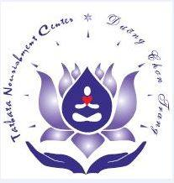
2019 body-mind purification retreat

start date: august 20,2019 end date: August 25, 2019
REGISTRATION FORM
Last Name: | First Name: |  |  |  |  |  | Middle Name:
Address: |  |  |  | City: |  |  |  |  | State/ Country: |  |  |  | Zip Code:
Phone: |  | Email Address: |  |  |  |  |  |  |  |  |  | Age: | Gender:  Male  Female

emergency contact information
Full Name: |  |  |  |  | Phone: |  |  |  |  | Relationship:

health history
List Your Health History:

Are You Allergy To Anything? If Yes, List Your Allergy:

Current Medications:

Any Other Special Conditions That We Need To Know:

Weight: |  |  | Blood Pressure: |  |  |  |  | :

WAIVER & MEDICAL RELEASE FORM
I,________________________________understand and voluntarily assume all risks of injury or illness as a result of my participation in this Body & Mind Purification Retreat. I agree to indemnify and hold harmless Ven. ThichTamThanh, the organizers and volunteers from and against every expense, including attorney fee, liability or payment by any reason of any damages or illness to person (including death) or property (including loss of use or theft thereof) arising out or in connection with my participation in this Retreat.

Signature: |  |  |  |  |  |  |  |  | Date:
* Note (Lưu Ý): Must fill out all lines or write N/A if not applicable

